Section A:
- Complete the gaps below.
Electrolysis

Comes from: Electro- -lysis

Electrolysis definition: _________________________________________________________________
________________________________________________________________________________

- Add the following labels to the diagram below.
The liquid that contains the ions (current is passed through)
Generates a current to flow through the electrolyte
Battery or power source
Positively charged electrode
Negatively charged electrode
Anode
Electrolyte
Cathode

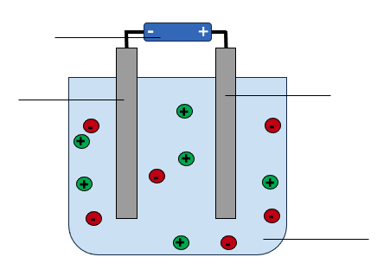

- Complete the table below to show the ions in different electrolytes.
Name of electrolyte | Positive ion (cation) | Negative ion (anion)
Potassium chloride

Zinc nitrate

Iron oxide

- Complete the sentences below.

- During electrolysis, passing an electric current through electrolytes causes the ______________________ to move to the electrodes.
- Positively charged ions move to the ______________________ electrode where they receive electrons and are ______________________.
- Negatively charged ions move to the ______________________ electrode where they lose electrons and are ______________________.

- Explain why an ionic compound must be liquid when used as an electrolyte.
___________________________________________________________________________
___________________________________________________________________________

- Explain why liquid ammonia (NH₃) cannot be electrolysed.
___________________________________________________________________________
___________________________________________________________________________
___________________________________________________________________________

Section B - Molten potassium fluoride can be electrolysed.

- Molten potassium fluoride contains ions.

- Explain why molten potassium fluoride can be described as an electrolyte.
___________________________________________________________________________
___________________________________________________________________________

- Write the chemical formula for potassium fluoride. _______________________

- State the ions present in potassium fluoride. _____________________________

- State which electrodes these ions move to during electrolysis.
___________________________________________________________________________

- At the negative electrode (cathode), ions gain electrons and are reduced.

Explain what happens to ions at the positive electrode (anode).
___________________________________________________________________________
___________________________________________________________________________

- State what is formed at each electrode.
Negative electrode _____________________________________________________________
Positive electrode _______________________________________________________________

- Write the half equations to show what happens at both electrodes during the electrolysis of potassium fluoride. (HT Only)
Negative electrode _____________________________________________________________
Positive electrode _______________________________________________________________

- The melting point of potassium fluoride is 858 °C.

- What state is potassium fluoride at room temperature (~25 °C)?
___________________________________________________________________________

- Explain why electrolysis of potassium fluoride cannot take place when it is at room temperature.
___________________________________________________________________________
___________________________________________________________________________

Section C - The table below shows some information about metals and their ores.

Metal | Source | First extracted | Extraction method
Platinum | Found as pure metal in the Earth | Used by ancient civilisations in South America | Removing from rocks
Zinc | Zinc oxide | c.1300 in India | Reduction with carbon
Magnesium | Magnesium carbonate  Magnesium chloride | 1808 by Sir Humphry Davy | Electrolysis

- Explain why platinum is found as pure metal in the Earth
___________________________________________________________________________
___________________________________________________________________________

- Zinc can be extracted from zinc oxide by reduction with carbon.

- Explain why carbon is used to extract zinc from zinc oxide.
___________________________________________________________________________
___________________________________________________________________________

- Write the word equation for this reaction.
___________________________________________________________________________

- Write the balanced symbol equation for this reaction.
___________________________________________________________________________

- Explain why magnesium was extracted much later than zinc and platinum.
___________________________________________________________________________
___________________________________________________________________________

- Electrolysis is used in industry to extract magnesium from magnesium chloride. Graphite can be used as electrodes because graphite is a good electrical conductor.
- Explain why graphite conducts electricity.
___________________________________________________________________________
___________________________________________________________________________

- State what is produced at the anode and cathode when magnesium chloride is electrolysed.
Anode ______________________________ Cathode ______________________________

- Suggest why other chemicals are added to the molten magnesium chloride to decrease the melting point of the mixture.
___________________________________________________________________________
___________________________________________________________________________

